Inclusive Involvement: Practical Steps You Can Take Today

A Friendly Guide to Equality, Diversity & Inclusion (EDI) in Public and Patient Involvement (PPI)






Acknowledgements
This practical guide has been shaped by the voices, experiences, and expertise of many individuals and organisations deeply committed to improving the landscape for rare diseases. Its creation would not have been possible without their generous contributions.
This document was also enriched by active participation and valuable input from attendees at two workshops. We thank the people who attended these workshops for their engaging discussion and valuable contributions. We gratefully acknowledge the support of the PPI Ignite Network @ UCD Seed Funding, which made this guide and the workshops that informed it possible.
We would also like to acknowledge the HRCI and RDCTN teams with a particular mention to Cassy Dinius who drove the initiative at all stages.
Finally, we are grateful to the following individuals who kindly reviewed this publication and provided very valuable feedback:
- Stacey Grealis, PPI Partner
- Dr Isaiah Gitonga, School of Psychology, University College Dublin
- Mr Dylan Keegan, UCD Clinical Research Centre, University College Dublin
- Marci Kay Livingston, PPI Partner
- Paula Leocadio, St John of God Research Foundation
- Yanet Morejon Hernandez, PhD Researcher, Department of Psychology and ALL
- Institute, Maynooth University

Equality Diversity Inclusion Onwards

Contents:
Welcome 4
PPI In Plain Language 5
EDI In Plain Language 6
Why EDI Strengthens PPI 7
Practical Ways to Be Inclusive 8
Learning From The Rare Disease Community 19
Tools and Resources 20
Just Give It A Try 21
Appendices 22
Practical Ways to Be Inclusive: Quick Reference 24
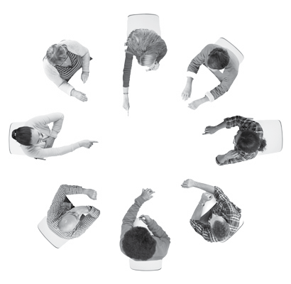



Welcome
This guide is about turning the ideas of equality, diversity, and inclusion (EDI) into practical action. We wanted to move beyond theory and show what you can actually do to make public and patient involvement (PPI) in research more welcoming and enjoyable for everyone.
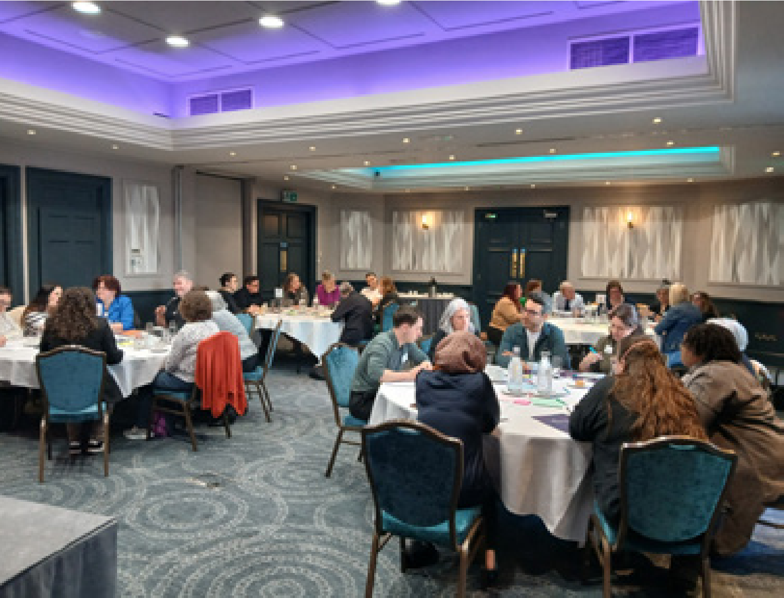
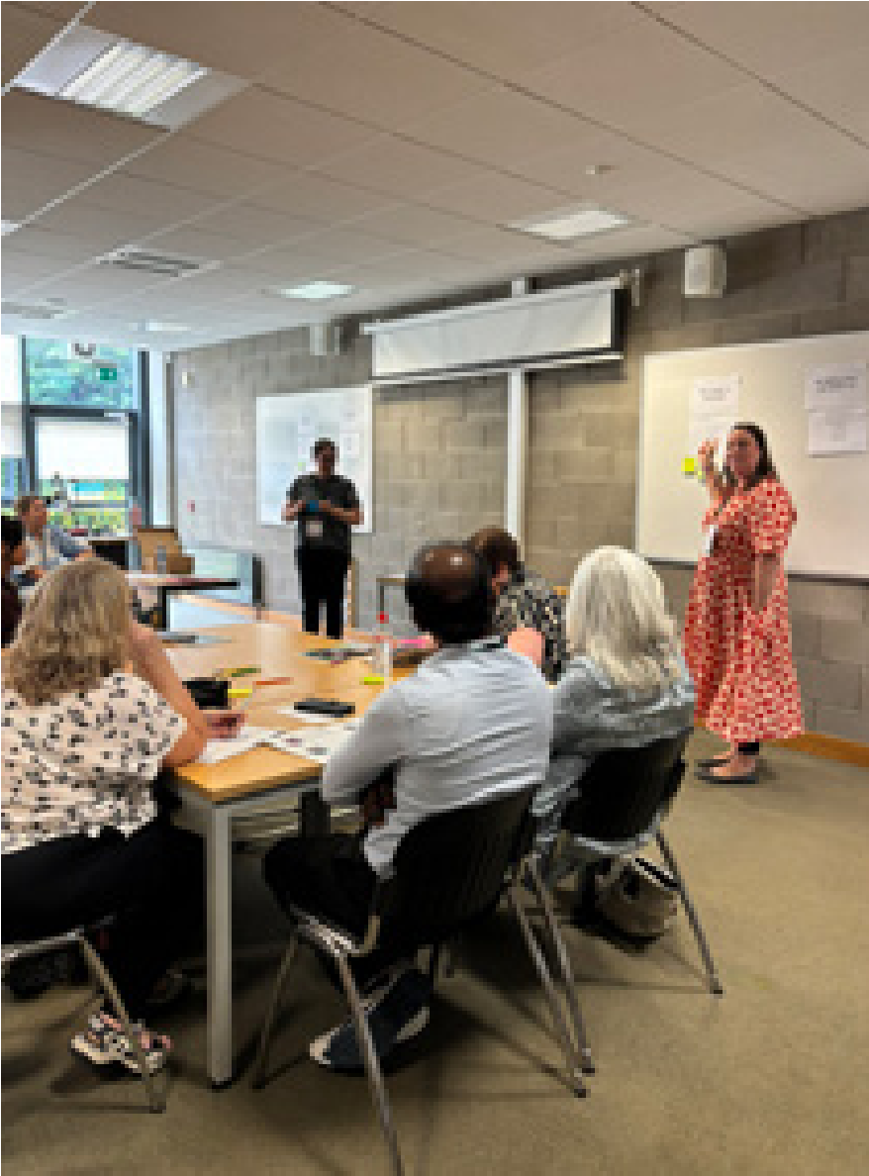
The inspiration for this guide comes from the rare disease community, where people living with rare conditions, their families, and charities have been calling for more inclusive approaches to involvement. Their insights and experiences shaped much of what you’ll read here. At the same time, the lessons and ideas apply well beyond rare diseases. They are relevant for anyone who wants to make PPI stronger and more inclusive.

This guide is for anyone involved in research, including patients, members of the public, researchers, research charities, PPI leaders, funders, and healthcare professionals. If you want to improve EDI in PPI, this guide is for you.
Inside, you’ll find clear explanations of what EDI means, why it matters, and practical, actionable ideas to make involvement more inclusive.


PPI In Plain Language
Public and patient involvement (PPI) is a way of doing research that supports collaboration between people with lived experiences and researchers.
People who take part in research might be referred to as participants, or subjects. That’s different from PPI, which refers to patients and members of the public actively contributing to and shaping how research is done. PPI means that research is carried out WITH or BY patients or members of the public rather than ABOUT, TO or FOR them.
Public and patient involvement is described in different ways across cultures. For example, in Canada it is often called ‘patient engagement’, while in Australia it may be referred to as ‘consumer involvement’. People who choose to get involved in PPI are called “PPI Partners”. They may also be referred to as contributors, co-researchers, patient advisors, lay representatives, and some people have their own preferred term. For the purposes of this guide, we will use the terms “PPI” and “PPI Partners”.
PPI can take many forms. For example, people might:
- Design research questions
- Write study materials to make them clear and easy to understand
- Decide how a study is run
The goal of PPI is to improve research and increase the ability of research to make a positive impact. PPI matters because it makes research more relevant, understandable, and useful for everyone. When patients and the public are involved, studies better reflect real-world experiences and needs.
We find it helpful to think about public engagement and involvement as a spectrum. A useful visual is the “avocado-shaped” UCD Spectrum of Public Engagement, shown on page 23.



EDI In Plain Language
Equality, Diversity, and Inclusion (often shortened to EDI) are about making participation fair and welcoming for everyone. Everyone brings a unique perspective, and communities, organisations, and projects all benefit when many different voices are represented.
Making people feel genuinely valued is essential. We’ve heard from PPI partners that sometimes they stop getting involved because they don’t feel equal or included. EDI isn’t only about fairness, but also for keeping PPI partners engaged and involved over time.
Equality means giving everyone the same resources and opportunities to contribute, no matter who they are. Sometimes, the ‘E’ in EDI can also refer to Equity which refers to providing individuals with the specific resources and support they need, rather than using a one-size-fits-all approach.¹
Diversity is about including people from all kinds of backgrounds, experiences, and perspectives. Diversity is very broad, it includes factors such as ethnicity, cultural background, gender identity, age, disability, socioeconomic background, sexual orientation, geographic location, religious affiliations, social class and other ways of being in the world that shape perspectives.
Inclusion is about making sure everyone feels welcome, respected, and able to contribute fully.
These three aspects work hand-in-hand, but in this guide we’re focusing on inclusion. Getting inclusion right helps maintain diversity. If people arrive and don’t understand the terminology or feel looked down on, they may be reluctant to return.
By creating an environment where everyone feels genuinely included, we can welcome people from all backgrounds and ensure their voices are heard.

https://ppinetwork.ie/wp-content/uploads/2022/01/PPI-Ignite-Network-EDI-Strategy-Dec2021.pdf



Why EDI Strengthens PPI
PPI is an essential part of health research. As awareness grows around EDI, there is a strong desire to make PPI more inclusive. When diverse voices are included, research becomes stronger.
Take asthma research, for example. Early studies mainly focused on adults from urban, white populations. Once researchers started including children, people from different ethnic backgrounds, and those living in rural areas, they discovered new triggers and differences in how medications worked. These insights improved treatment and guidance for everyone. Inclusive research isn’t just fairer, it’s smarter.
People bring different perspectives, ways of being in the world, and ideas that can uncover challenges and solutions researchers might not otherwise consider.
PPI brings experience into the light, bringing awareness to the challenges, the curiosities, and the wonderful things. Then, we can ask the research questions that need to be asked, the ones that won’t even come up unless someone makes these hidden realities visible.
-Geraldine Halpin, mother of an adult son with a rare disease
When involvement processes are welcoming and inclusive, people feel more confident and comfortable contributing, and they are more likely to stay engaged over time. By prioritising inclusion, researchers can make sure their work reflects the needs of a broad community, producing results that are useful, applicable, and fair for all.



Practical Ways To Be Inclusive
Understanding inclusion is just the starting point. To truly embed EDI in PPI, we need to move from good intentions to meaningful action. The ideas below are designed to support you to do that.
We hope they encourage PPI that is not only more ethical, but also stronger, more relevant, and better able to reflect the needs of everyone involved.
Each idea follows a simple format to help you move from thought to practice:
- A topic (in bold)
- A reflective question to consider
- A concrete practical idea you can implement
We know that guidance like this can sometimes feel overwhelming or unachievable, especially for those with limited time and resources. Think of these suggestions as a starting point that you can build on over time. Many of the tips could be prefaced with “when possible”. The goal is to be thoughtful and practical (not perfect!) and certainly not for this or other guidance to make anyone feel judged or guilty.
These ideas are organised roughly in the order of a project or initiative, but they can be used in many different ways. They may guide your planning, or they may spark discussion in a team or project.



Inviting People Into Partnership

Build Relationships Early
Reflective question: Is your first contact with a community an ‘ask’ for something?
Practical idea: Build trust by connecting with community groups and individuals before you need their input. Try inviting them to an event or attending one of theirs!

Be intentional about diversity
Reflective question: Are your PPI partners all from similar backgrounds?
Practical idea: Actively reach out to PPI Partners with a range of identities, including gender, socioeconomic status, disability, ethnicity, age, and geographic location. Community organisations and charities can be a great first contact. Where you advertise PPI opportunities will reflect who sees them and engages. LinkedIn will bring a very different audience to a community noticeboard or a TikTok post!

Address the confidence gap
Reflective question: Could potential PPI Partners be hesitant to join because they feel their experience is insufficient?
Practical idea: Be explicit about the specific types of experiences or viewpoints you are looking for. “All are welcome, and we are particularly keen to hear from people with lived experience of [specific issue] or those who have supported someone through [specific situation].”

Embed diversity in decision-making
Reflective question: Whose perspectives shape the direction of the project?
Practical idea: Include diverse voices on advisory boards, steering committees, and in leadership roles. This models representation while ensuring decisions reflect a wide range of perspectives.



Inviting People Into Partnership

Track and learn from diversity
Reflective question: Do we understand who is involved, and are we noticing any gaps in inclusion?
Practical idea: Collect anonymised demographic information to see who is (and isn’t) represented. Review this regularly, share findings transparently, and guide actions that broaden inclusion over time. Even small changes can make a lasting impact.

Use symbols of safety
Reflective question: How do you show someone you are an ally before you even speak?
Practical idea: Signal your commitment to inclusion with visible signs like adding pronouns to your email signature or displaying cultural emblems appropriate to your PPI group. For example, flags, music or inclusion symbols are reassuring as long as they are backed up by genuine inclusive practice.

Offer support and mentorship
Reflective question: Do PPI Partners have access to guidance or peer support?
Practical idea: Offer optional mentoring or peer-support opportunities, recognising that expertise flows both ways. Provide resources like a ‘Welcome Kit’ to support them. This is valuable for everyone, and especially for people from underrepresented communities.

Use the community’s own language
Reflective question: Does the language label the community, or does it label the systemic barrier they face?
Practical idea: Avoid imposing clinical or academic terms on personal experiences. Contributors will define their world in their own words, so listen for the specific phrases people use or ask what they prefer. Some terms used in research, such as ‘hard to reach’, can feel blaming or dismissive. Using terms like ‘underrepresented communities’ instead, highlights the responsibility on systems rather than individuals.




Nurturing Partnership

Induct and train all team members
Reflective question: What training might benefit your team?
Practical idea: Provide a shared induction for all team members to build a shared foundation. This could be followed by targeted training: offering PPI partners a course on the research process, while providing research partners with courses on cultural competency, cultural humility, trauma-informed practice, and power dynamics.

Plan for compensation and recognition
Reflective question: Are PPI Partner payments included in the budget? Beyond payment, have you asked what recognition would feel meaningful?
Practical idea: Ask what form of compensation is best. Consider that some payments can impact on social welfare benefits and tax. In addition, discuss forms of recognition such as co-authorship, co-presenter roles, group lunches or award nominations.

Gather only what data/information you need
Reflective question: Have you explained why sensitive information is being requested?
Practical idea: Review all forms and remove any non-essential questions. Only ask for sensitive information, like home addresses or sexual orientation, if it is truly needed and in compliance with GDPR and ethical standards. Explain why you are collecting it (for example, noting that sexual orientation is used to improve diversity and representation) so people feel more comfortable sharing.
Nurturing Partnership

Offer a single point of contact
Reflective question: If a PPI Partner has a question, do they know who to ask?
Practical idea: Assign one person to be the main contact to build rapport and avoid confusion.

Get to Know Each Other as People
Reflective question: Are you engaging with partners beyond their role in the project, and showing yourself as a person too?
Practical idea: Take the time to get to know each other as people, not just within the project roles. Recognise your cultures, languages, life experiences, and other identities. Share appropriate personal information about yourself to build trust and rapport.

Create inclusive forms
Reflective question: If a person’s identity isn’t represented in the options, what message might that send?
Practical idea: Make your materials more welcoming by expanding the options for identity-based questions (gender, pronouns, sexuality, ethnicity and identity). Go beyond binary choices, as limited options can feel alienating. When providing a write-in option, use “Self-describe” or “Not listed” instead of “Other,” which can feel exclusionary. Always allow people to opt out by including a “Prefer not to say” option. Find more in the ‘Tools & Resources’ section of this guide.



A Friendly Guide to
Equality,

Diversity
and
Inclusion

Enabling Partnership

Be open to communicating in various ways
Reflective question: Can everyone share their thoughts in a way that works for them?
Practical idea: Encourage multiple ways to communicate, such as spoken, written, visual, or recorded formats. This could include email, photos, diagrams, voice notes, or other methods that suit peoples’ needs, preferences and communication styles.

Embrace flexibility
Reflective question: Could rigid timelines or procedures unintentionally exclude some people?
Practical idea: Adapt your approach to meet people’s needs and circumstances. Be open to adjusting timelines, formats, or locations. For example, shift meetings from afternoons to evenings if that works better for PPI partners’ schedules.

Be mindful of digital tools
Reflective question: If someone doesn’t have a strong internet connection or specific software, can they still be involved?
Practical idea: Take into account people’s access and privacy needs. Ask which platforms and formats work best for people. For example, some may have limited internet bandwidth, or use screen readers that don’t work well with certain scheduling tools like Doodle. Also consider that some platforms require users to share an email address, while others allow participation without revealing personal details. Find more in the ‘Tools & Resources’ section of this guide.

Enabling Partnership

Support Flexible Pacing
Reflective question: If someone processes information in a different way, can they still contribute?
Practical idea: Some people benefit from additional time to process, or may need to use assistive technology like language translators or screen readers. To support this, when possible, provide materials in advance so people can review them and prepare ideas or questions. Offer ways that people can follow up afterwards, too. This encourages people to share ideas at their own pace.

Meet in an accessible, neutral space
Reflective question: Are travel, parking, and signposting easy for everyone attending?
Practical idea: Hold meetings in local, community settings. Check that venues are fully accessible, including step-free access and suitable bathrooms. Consider practicalities like nearby parking or public transport. For example, universities may be difficult if they have limited parking or if public transport is infrequent.

Allow for personalisation
Reflective question: Can the lighting or temperature be changed? Does the seating accommodate a variety of body shapes, mobility aids or accessories?
Practical idea: Whenever possible, allow individuals to adjust their environment to meet their sensory and physical needs. Provide a separate space (‘quiet room’) where people can rest and recharge.

Enabling Partnership

Encourage support
Reflective question: Could having a friend, family member, or advocate present make it easier?
Practical idea: Invite PPI partners to bring someone they trust, such as a friend, family member, or advocate. This can help people feel more comfortable and supported. It can also build confidence in contributing, particularly in settings that might feel intimidating or unfamiliar. Make clear how confidentiality will be managed if supporters are present.


Honouring Partnership

A Friendly Guide to
Equality,

Diversity
and
Inclusion

Ask for feedback
Reflective question: What should you do again next time? What might need to change?
Practical idea: Request direct feedback on PPI activities to understand what worked well and what didn’t. Allow for multiple ways of giving feedback - we recommend RIX Software as an example.

Report back
Reflective question: Do PPI Partners know what happened after they gave their input?
Practical idea: Follow up regularly to communicate the difference that PPI made. Consider setting a regular calendar reminder to reach out with an update.

Revisit compensation and recognition
Reflective question: Have PPI Partners been compensated and recognised?
Practical idea: Keep partners up to date on agreed arrangements for payments and other forms of recognition.

Manage research fatigue
Reflective question: Are the same PPI partners being relied on repeatedly?
Practical idea: Rotate short-term and long-term opportunities across a wider community to prevent burnout.

Honouring Partnership

Check in
Reflective question: Has anyone’s availability or willingness to participate changed over time?
Practical idea: For longer-term partnerships, regularly ask, “Do you still wish to be involved?” for long-term partnerships.

Say ‘Thank You’ and also say ‘Goodbye’
Reflective question: Have PPI Partners been thanked and informed that the project is concluded?
Practical idea: Communicate the project end date, discuss potential future collaboration, and consider marking completion with a small celebration.

Learning From The Rare Disease Community
This guide began with, and was shaped by, the rare disease community. From the very beginning, people living with rare diseases, their families, patient organisations, researchers, and PPI partners were central to the conversations that inspired this work. Their experiences, challenges, and ideas helped define the values, direction, and practical focus of the guide.
The rare disease community is highly diverse and spans different ages, ethnicities, abilities, and socioeconomic backgrounds. In Ireland, around 300,000 people live with a rare disease. Because 80% of rare conditions are genetic and often begin in childhood, individuals and their families accumulate decades of firsthand knowledge¹ Compounded by a frequent lack of medical expertise, they become experts in managing their own health, advocating for care, and navigating complex systems. This deep, lived expertise is an invaluable resource for research.
To turn EDI theory into practical action, we designed and hosted collaborative workshops that brought together people with lived experience, charity advocates, researchers, and EDI experts. The workshops created space for honest discussion, shared learning, and co-creation. Participants explored what genuine inclusion looks like and developed practical ideas for how to achieve it. These insights form the foundation of this guide.
Although this guide grew from the rare disease context, the lessons and approaches shared here reach far beyond it. The principles of inclusive involvement are universal.
The full workshop methodology and findings will be published soon in an academic paper, available via rarediseaseresearch.ie.

1 Baynam, G., Hartman, A. L., Letinturier, M. C. V., Bolz-Johnson, M., Carrion, P., Grady, A. C., ... & Groft, S. (2024). Global health for rare diseases through primary care. The Lancet Global Health, 12(7), e1192-e1199.

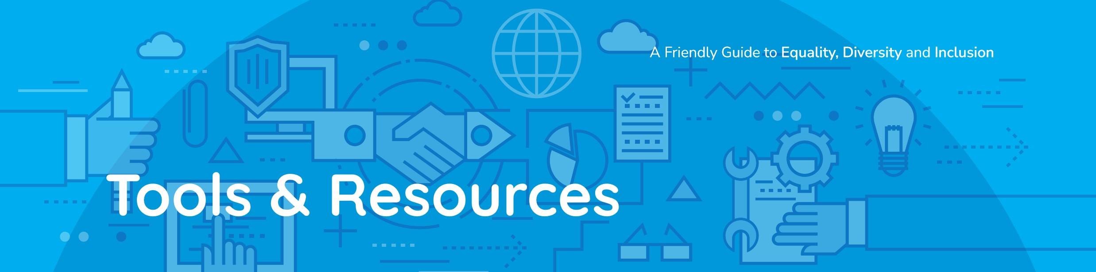
Engaging in inclusive PPI requires a diverse set of skills - from clear communication and cultural sensitivity, to effective facilitation and thoughtful event planning. Rather than reinventing the wheel, it can be helpful to see what others have done. Below are some valuable resources that can support your journey towards more inclusive PPI practices.
- Plain English resources, from National Adult Literacy Agency (NALA): https://www.nala.ie/publications/?_publications_categories=plain-english-resources

- Public and Patient Involvement resources, from Health Research Charities Ireland (HRCI): https://hrci.ie/publications/patient-public-involvement/

- Facilitators guide and checklist from PPI Ignite: https://ppinetwork.ie/wp-content/uploads/2024/10/Evaluating-PPI-Training-FacilitatorGuide-Checklist-V1.pdf

- The Facilitator’s Toolkit, from the National Health Service (NHS): https://www.england.nhs.uk/improvement-hub/wp-content/uploads/sites/44/2017/11/Facilitator-Toolkit.pdf

- Checklist for Asking about Sex/Gender Identity, from Queen’s University Belfast (QUB): https://www.qub.ac.uk/directorates/HumanResources/diversity-and-inclusion/ TransEquality/Checklist-AskingaboutSexGenderIdentity/

- Talking about involvement in research: How can we do this in an accessible way to ensure we encourage a range of people to get involved, from Egality: https://egality.health/wp-content/uploads/2022/09/involvementinreserch.pdf

- Improving Diversity in Health Research and Trials, A Conversation with Medical Research Charities, from Egality: https://egality.health/wp-content/uploads/2022/09/Egality-Improving-diversity-inhealth-research-and-trials.pdf

A Friendly Guide to
Equality,

Diversity
and
Inclusion

Just Give It a Try
Taking practical steps to improve EDI in PPI can sometimes feel daunting. It’s natural to worry about getting it “right” or making mistakes. But inclusion isn’t a neat checklist, it’s a dynamic, human process that grows as you learn. What matters most is being willing to start, to listen, and to adapt.
You won’t always be able to meet everyone’s needs in exactly the same way, and that’s okay. What counts is how you respond. For example, if six people prefer to meet in person and two prefer online, inclusion means acknowledging the difference and asking, “How can we make this work?” You might offer extra support for in-person attendance or arrange a short online catch-up to ensure everyone’s input is heard.
Small, thoughtful actions like these build trust and inclusion. The goal isn’t perfection, it’s progress. Start with one change in your next involvement activity, notice what works, celebrate small wins, and build from there.
Inclusive involvement benefits everyone: researchers, PPI partners, and the wider community. Every effort, no matter how small, helps create a more welcoming and meaningful experience for all.
Inclusion is a journey, not a destination. Keep asking, listening, learning, and adapting. Your commitment to making involvement accessible and respectful contributes to stronger research and a fairer society.

A Friendly Guide to
Equality,

Diversity
and
Inclusion

Appendices

About the Rare Disease Clinical Trial Network (RDCTN):
Our mission is to be a support and collaboration hub that links and develops national and international rare disease expertise and innovation while keeping the patient voice at the centre of all our work.
We aim to increase the quality and quantity of rare disease clinical trials that Irish patients can access. We provide support for rare disease clinical trial design and set-up to researchers, clinicians, industry and patients. We aim to make rare disease clinical trials more inclusive by improving trial design and accessibility in partnership with patients and patient advocacy groups. We highlight education and training for early career researchers in rare disease research and clinical trials.



About Health Research Charities Ireland (HRCI):
Health Research Charities Ireland (HRCI) is the national umbrella organisation of over 45 charities engaged in health, medical and social care research, collectively representing over 2 million people in Ireland. We champion our members’ interests, to enhance the environment for health research in Ireland. We empower them to realise our shared vision of improving lives through impactful research.
We offer our members the potential for matched research funding through the Joint Funding Scheme, run in partnership with the
Health Research Board. We also run the Irish Health Research Forum, bringing together all stakeholders to improve health research in
Ireland. www.hrci.ie


LECTURES/
TALKS
EXHIBITIONS
SHOWCASE
OPINION
POLLS
PEOPLE’S
PANELS
FOCUS
GROUP ON
RESEARCH
TOPIC
ADVISORY/
USER
COMMITTEE
CITIZEN
JURY
INFORMING/INSPIRING
STIMULATING THINKING
UNDERSTANDING THINKING
INFORMING DECISION-MAKING
COLLABORATING
PARTICIPATIVE
ACTION RESEARCH
COLLABORATING
PARTNERSHIP
SHARED-DECISION
MAKING
COMMITTEE

REPRESENTATION
STAKEHOLDER

DIALOGUE
PUBLIC

AS
RESEARCHERS

CITIZEN SCIENCE
(
)
CONSULT-
ATIONS
ATTITUDE
RESEARCH
SOCIAL
RESEARCH
SURVEYS
EDUCATION
PROGRAMME
SCIENCE
CENTRES
THEATRE IN
EDUCATION
PUBLIC
DEBATE
INTERACTIVE
WEBSITES
SCIART
FESTIVALS
PODCASTS
BLOG
LIBRARY
RESOURCES
MAGAZINE
ARTICLE
NEWSLETTERS
TV
PROGRAMME
WEBSITE
RADIO
WEBINARS
SOCIAL
MEDIA
NEWS/
NEWPAPER
COVERAGE

CO-PRODUCING

CONSULTING
INFORMING/INSPIRING
DIALOGUE
INFORMATION
Based on Wellcome Trust Public Engagement ‘Onion’- Adapted by the UCD Public Engagement Working Group

i

We find it helpful to think about public engagement and involvement as a spectrum.
This “avocado-shaped” UCD Spectrum of Public Engagement, shows varying levels of dialogue and collaboration.

Practical Ways to Be Inclusive: Quick Reference
Inviting Partnership Nurturing Partnership

Build relationships early
Practical idea: Build trust by connecting with community groups and individuals before you need their input.

Be intentional about diversity
Practical idea: Reach out to PPI Partners
with a range of identities. Community
organisations and charities can be a great first contact.

Address the confidence gap
Practical idea: Be explicit about the specific experiences you are looking for.

Embed diversity in decision-making
Practical idea: Include diverse voices on
advisory boards, steering committees, and in leadership roles.

Track and learn from diversity
Practical idea: Collect anonymised
demographic information to see who is (and isn’t) represented.

Use symbols of safety
Practical idea: Signal your commitment
to inclusion with visible signs like adding
pronouns to your email signature.

Offer support and mentorship
Practical idea: Offer optional mentoring or peer-support opportunities, recognising that expertise flows both ways. Provide resources
like a ‘Welcome Kit’ to support people.

Use the community’s own language
Practical idea: Contributors will define their world in their own words, so listen for the specific phrases people use or ask what they prefer.

Induct and train all team members
Practical idea: Provide a shared induction for all team members to build a shared foundation.

Develop a partnership ‘Terms of
Reference’
Practical idea: Co-create a document with PPI Partners outlining mutual expectations,roles and responsibilities. Revisit it regularly.

Plan for compensation and recognition
Practical idea: Ask what form of
compensation is best and discuss forms of recognition.

Gather only what data/information you
need
Practical idea: Remove any non-essential questions and explain why you are collecting information so people feel more comfortable sharing.

Offer a single point of contact
Practical idea: Assign one person to be
the main contact to build rapport and avoid confusion.

Get to know each other as people
Practical idea: Share appropriate personal information about yourself to build trust and rapport.

Create inclusive forms
Practical idea: Make your materials more
welcoming by expanding the options for
identity-based questions.

Be open to communicating in
various ways
Practical idea: Encourage multiple ways to communicate and respond, such as spoken, written, visual, or recorded formats.

Embrace flexibility
Practical idea: Be open to adjusting timelines, formats, or locations.

Be mindful of digital tools
Practical idea: Ask which platforms and
formats work best for people. Consider low- bandwidth connections, and be mindful of privacy.

Ensure understanding for all
Practical idea: Provide materials in advance so people can review them and prepare. Offer ways that people can follow up afterwards, too.

Meet in an accessible, neutral space
Practical idea: Hold meetings in local,
community settings. Check that venues are fully accessible.

Allow for personalisation
Practical idea: Provide a separate space
(‘quiet room’) where people can rest and
recharge.

Encourage support
Practical idea: Invite PPI partners to bring someone they trust, such as a friend, family member, or advocate.

Ask for feedback
Practical idea: Request direct feedback on PPI activities to understand what worked well and what didn’t.

Report back
Practical idea: Follow up regularly to
communicate the difference that the PPI
made.

Revisit compensation and recognition
Practical idea: Keep partners up to date on agreed arrangements for payments and other forms of recognition.

Manage research fatigue
Practical idea: Rotate short-term and long-term opportunities across a wider community to prevent burnout.

Check in
Practical idea: For longer-term partnerships, regularly ask, “Do you still wish to be involved?”

Say ‘Thank You’ and also say ‘Goodbye’
Practical idea: Communicate the project end date, potential future collaboration, and mark completion with a small celebration.

Chung, C. C. Y., Hong Kong Genome Project, Chu, A. T. W., & Chung, B. H. Y. (2022). Rare disease emerging as a global public health priority. Frontiers in public health, 10, 1028545.
https://rarediseaseresearch.ie/public-patient-involvement/
https://hrci.ie/the-language-of-patient-and-public-involvement-and-how-not-to-mess-it-up-2/

